The Twitter page @WeRateDogs is a wholesome account that assess the quality and attributes of doggos, floofers, puppos, and puppers. They eloquently deliver these results to their audience and to no surprise every good boy lives up to their merit.

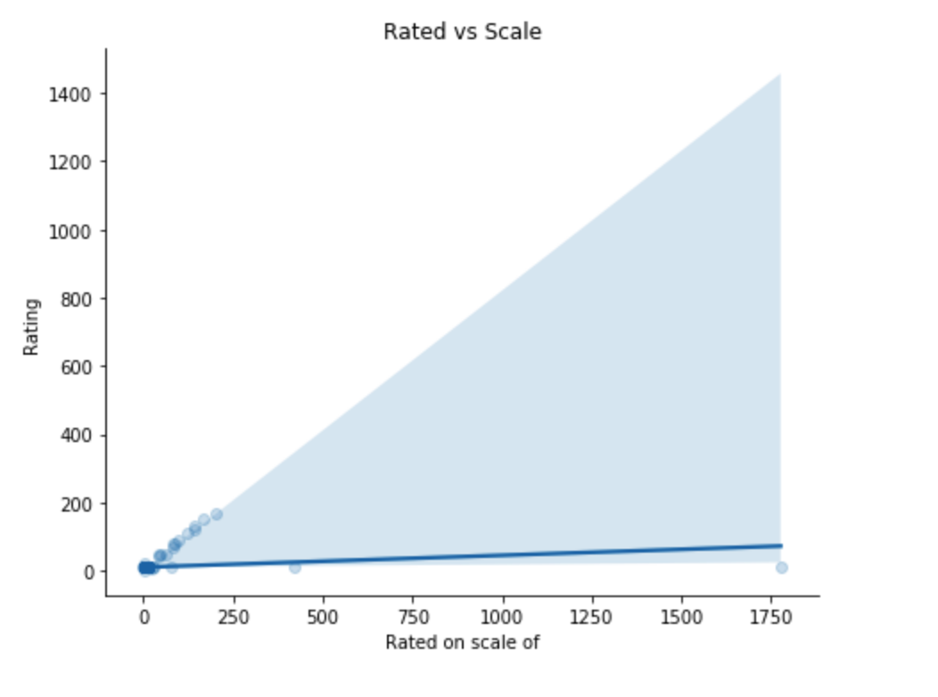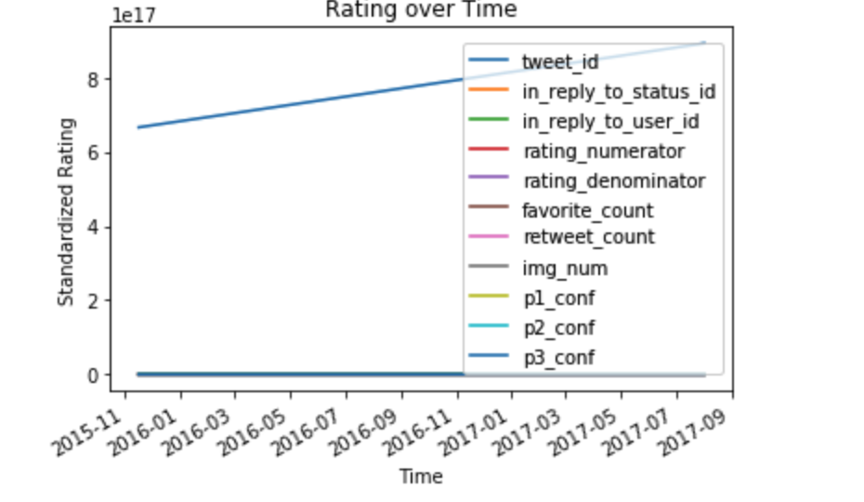Here we can see the standardized rating increases steadily over the years, beginning from 2015 and moving through 2017

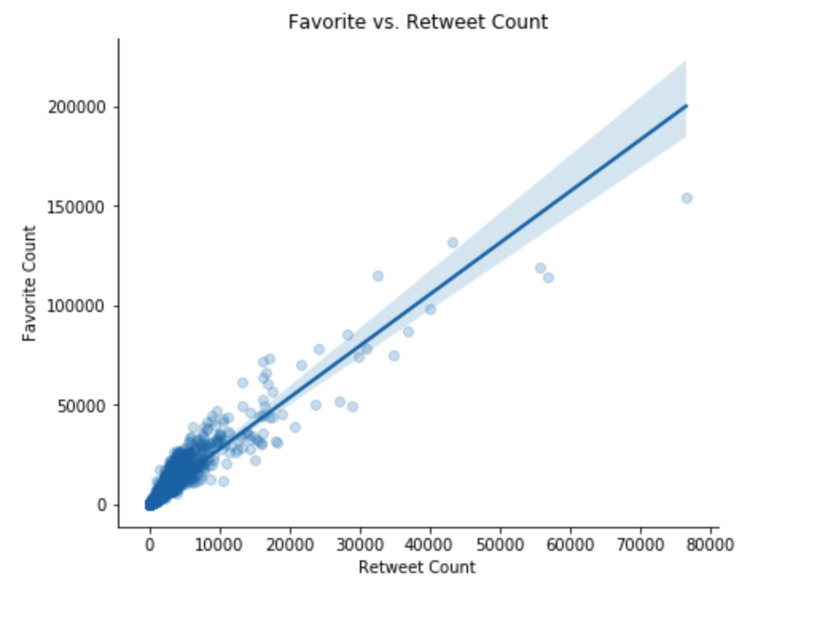If we compare the rating of the dogs compared to the maximum rating possible we can observe that most if not all the dogs meet the highest value possible. We also have two outliers for which we can assume these were the goodest good boys. However all the boys were really good boys.

Amongst the users who view the tweets and all the good boys 1 in 4 that like a tweet will retweet also. There is a positive correlation between the two and the trend is based on thousands of data points.

We can conlude that the popularity of the dogs is steadily increasing, although most of the good boys are doing very well on the scale themselves. Around %25 percent of those liking these tweets also retweet, indicating a positive correlation that is going to increase over the years.